Current Object

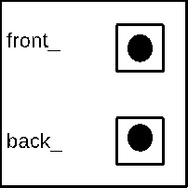



23



15



10



8



rhs





23



15



10



8

